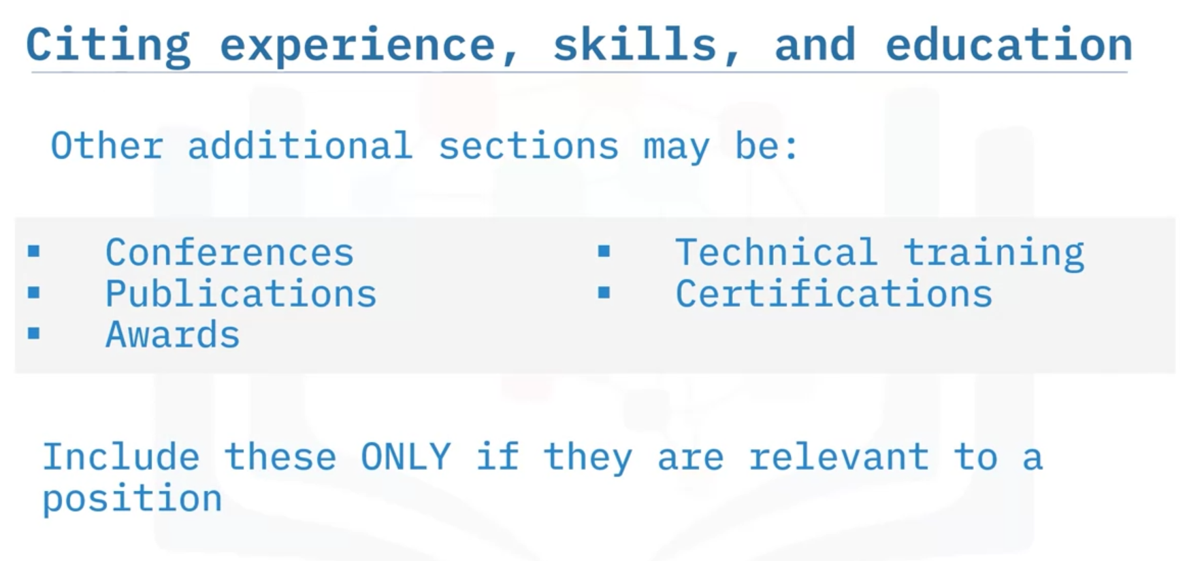

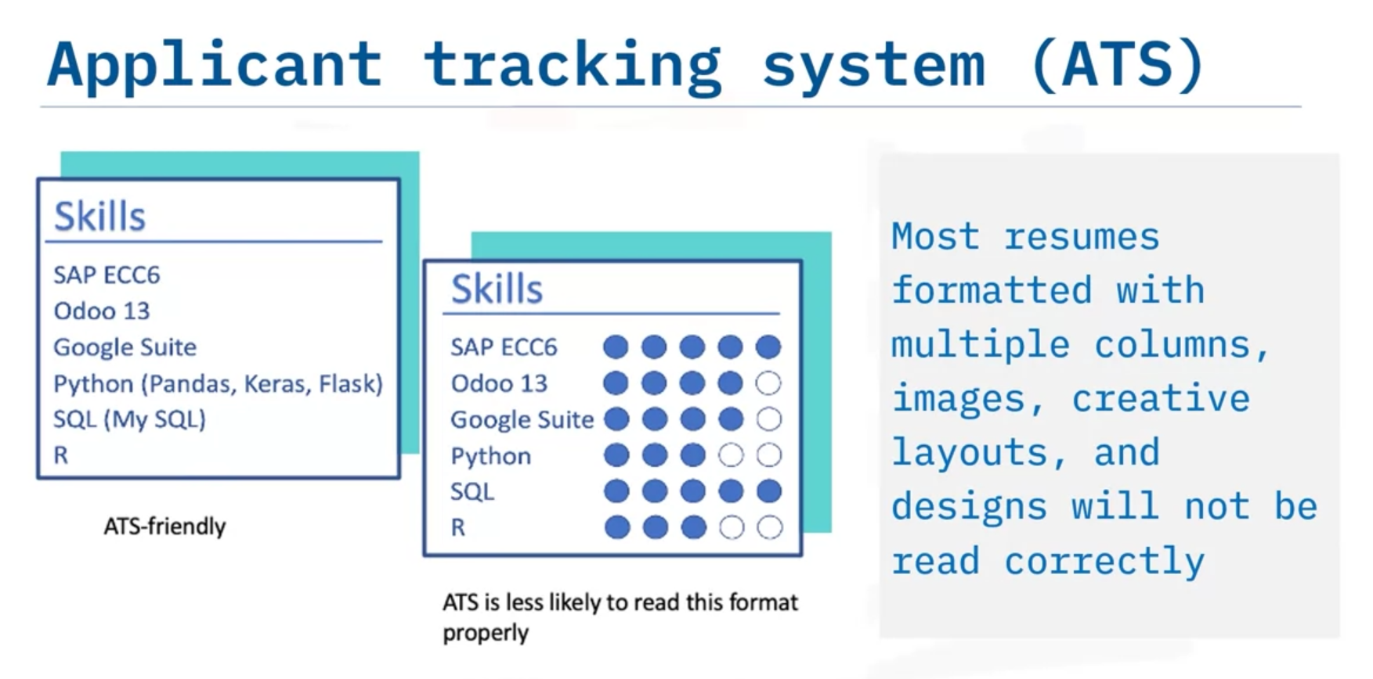

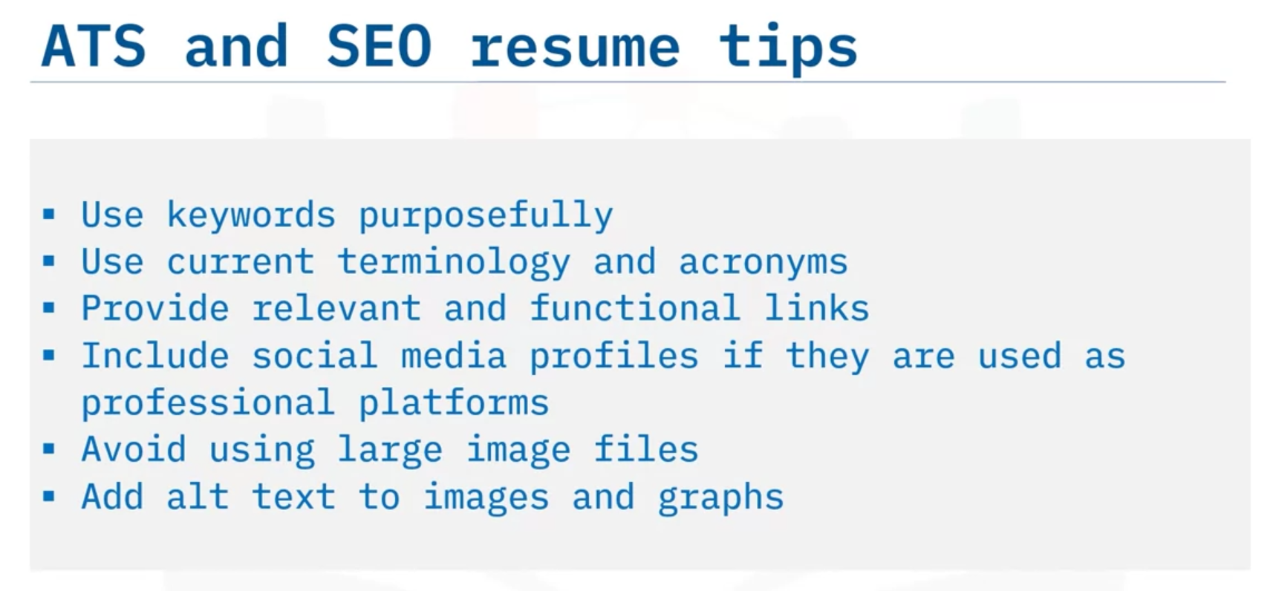

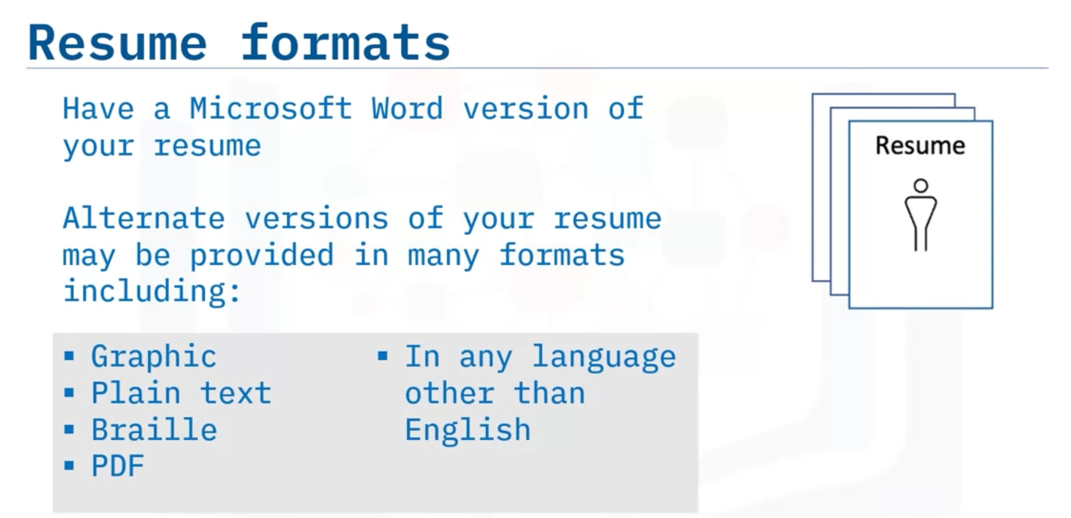

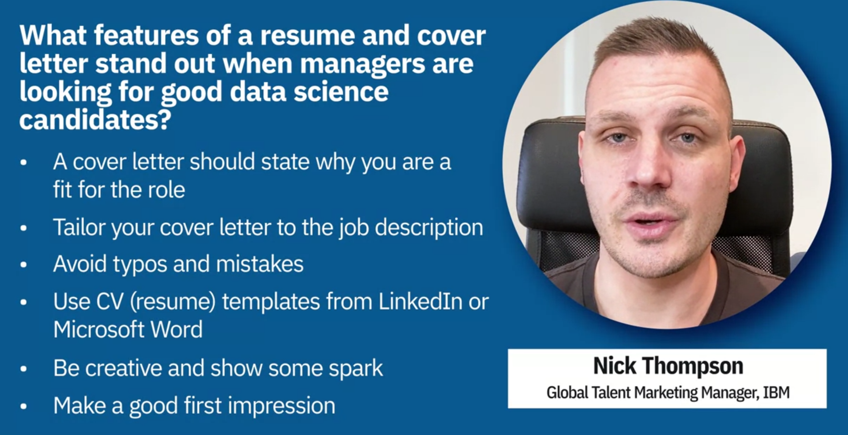

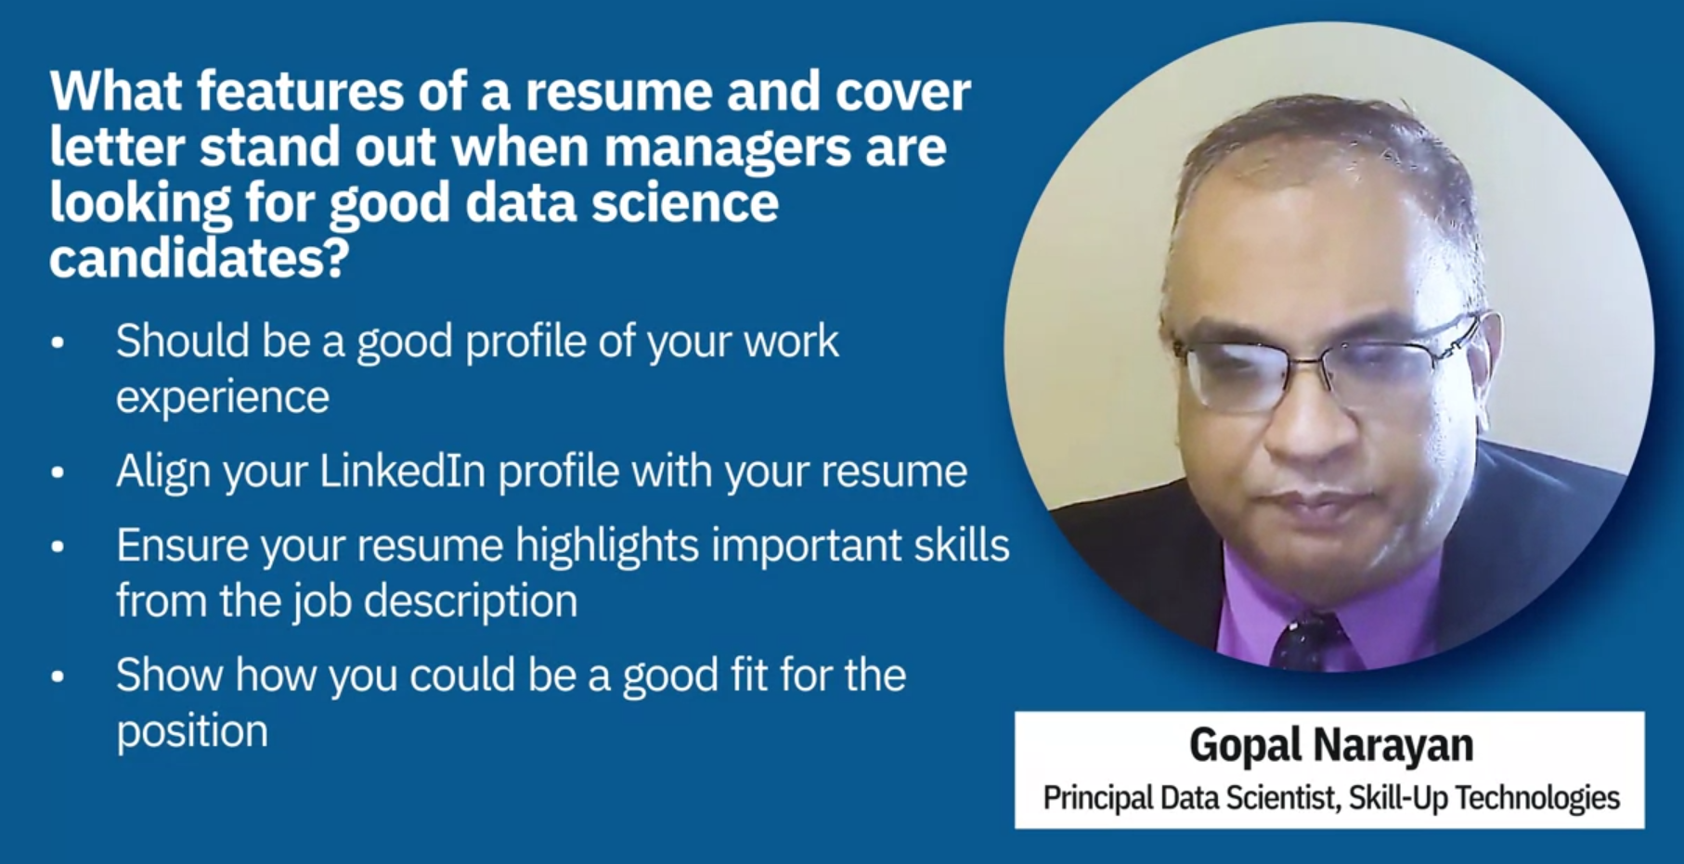

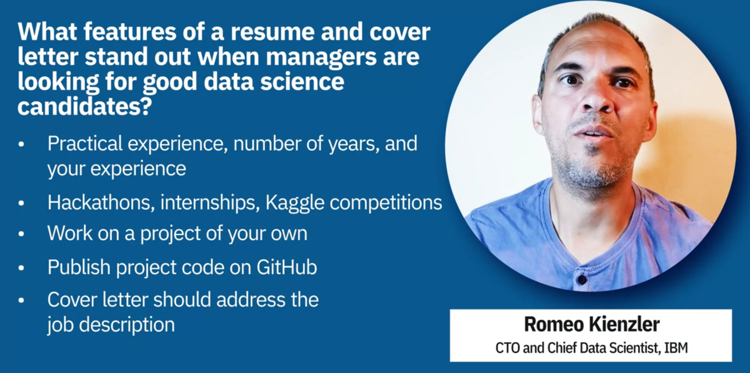

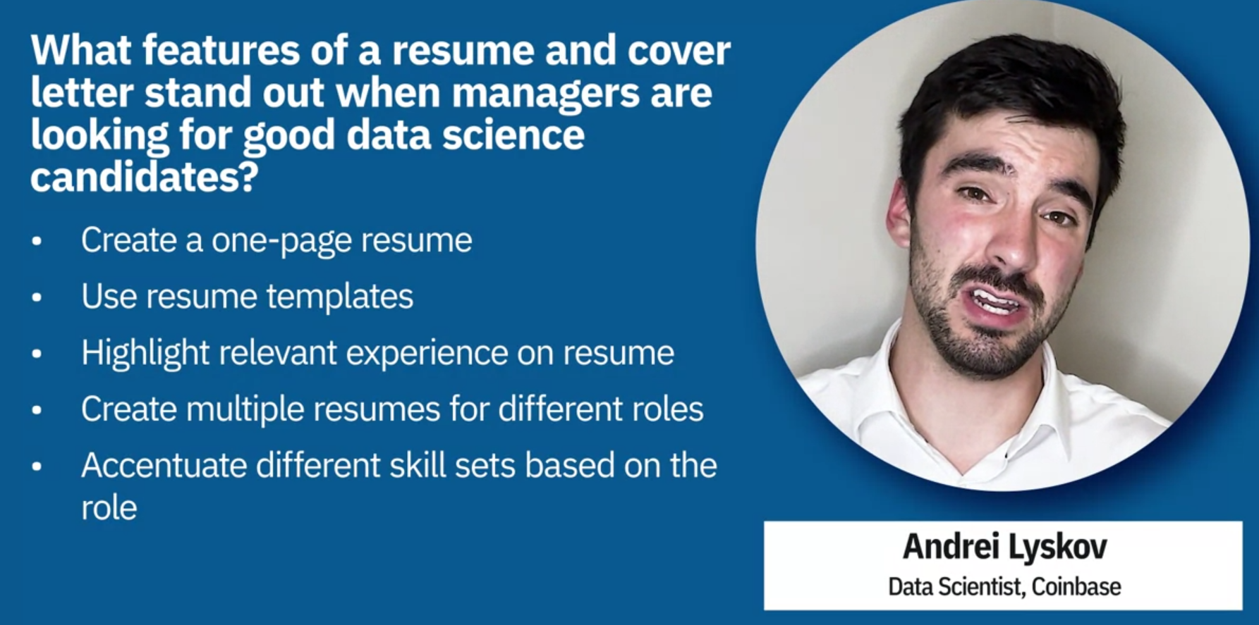

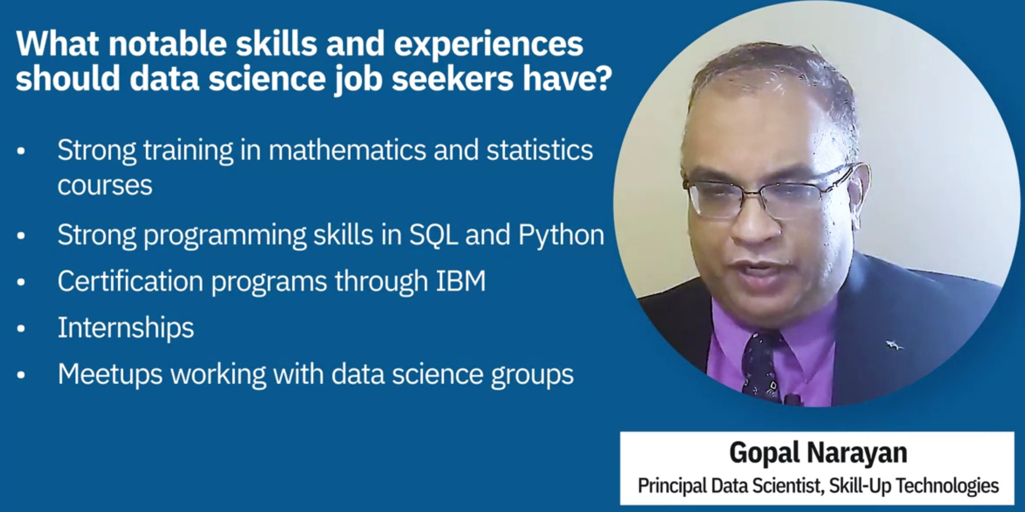

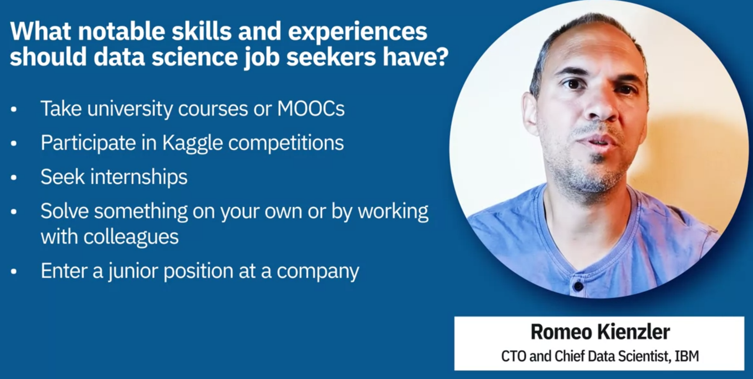

# Draft Your Resume

**Estimated time needed:** 60 minutes

Welcome to the hands-on lab for Draft Your Resume. In this lab, you will go through the steps of drafting a basic resume. This resume will contain the common sections and building blocks in a typical resume, and you can edit it later to include specifics about a particular job you want to apply for.

## Learning Objectives

After completing this lab, you will be able to:

* Create a basic resume
* Describe how to edit the resume to fit different job applications

## Prerequisites

You will need the following to complete the exercises in this lab:

* Word processing software
* A source of information about your past work experience and skills
* An example job listing to practice tailoring the resume to a specific role

## Keep in mind

* You will probably want to keep a copy of your resume in Microsoft Word (.doc) format, since it’s the format companies will ask for more than others. It’s also useful to save the resume in plain text, because that will make it easier to cut and paste into a website field.
* Try to keep your resume brief and succinct. It should very rarely be longer than two pages.
* You can use your example job listing to edit the information in your resume and practice tailoring it. You will probably do this most times that you apply to a new job.
* As you work, highlight the parts of your resume that are likely to change. This will make it easier to find and change them in the future.

## Should you use a template?

Many resume templates are available online and elsewhere, and these can simplify composing a resume and giving it an interesting layout. However, you need to use caution because many of them are not readable by applicant tracking software. If a potential employer is using that software to screen incoming resumes, they may miss your resume if it can’t be scanned. It’s better to draft your resume in a plainer format and have that on hand – you can always paste it into a template later.

## Exercise 1: Contact information

In this exercise, you will open and start your resume.

1. Open a new document in your word processor.
2. Write your name at the top. This is usually centered on the page, although it could be flush to the left. Use your legal name, or a nickname if that is what you’re usually called in professional situations.
3. Under your name, write your contact information. Include a phone number and email address at least. A street address is not necessary, but your town and state can be helpful. Carefully check that your phone number and email address are correct. Also, make sure your email address looks professional.
4. Include links to social media or websites if you are using them for professional networking. Be sure everything on these accounts is something you want potential employers to see.

## Exercise 2: Write a summary

In this exercise, you will write a summary of your resume.

The top of the first page of your resume is the most important part of it. A manager will only look at each resume for a few seconds before deciding whether or not to continue, so catching their attention quickly in the top section is crucial.

1. You can start with a one-sentence description of who you are and what you are looking for. For example:

Data science graduate looking for an entry-level position in the field of medicine and health care.

1. Add a section where you list your specific technical skills. You will definitely edit this section to fit different job listings, but for now, include whatever skills you can think of. This can include skills specific to your field (such as machine learning expertise) and other specific skills (such as languages and tools you know how to use).

## Exercise 3: List professional experience

In this exercise, you will compose the largest part of your resume, your professional experience.

1. Start with your current or most recent position. List your title, the company, and the date you began and ended the job.
2. When providing information about your work experience, follow this pattern with your statements: use an action word, then the task you worked on, and then the result in quantifiable terms if possible. Some action words include initiated, constructed, converted, deployed, led, and designed. For example:

“Deployed improved database design, which increased efficiency by 25% and saved 15% in storage.”

1. Include the major tasks and duties you performed in that position, but stay aware of length. You don’t want to overwhelm, and you should keep your whole resume to under 2 pages, so concentrate on the most important or relevant information.
2. Working back, list all of your previous roles in reverse chronological order. Write them out the same way you wrote the most recent job. If you have more than 8-10 years of experience, only list the most recent few years.

## Exercise 4: List your education

In this exercise, you will include your educational credentials.

1. Write in your educational achievements. You will want to list any degrees you’ve earned, of course. List the school, the degree, and the major. You may want to add significant focuses or classwork you completed as well. Dates can be useful, but they can also indicate your age and lead to discrimination, so you may want to leave them out.
2. Add any other educational content you may have, including certifications, standalone courses, and so on, if you have them.

## Exercise 5: Optional sections

There are some sections you can add to your resume if you are new to the job market and don’t have a lot of work experience to list.

* If you have independent projects, you can list them in a Projects section. This can highlight your skills and some ways you have used them outside a professional setting. Include links to this work if possible, especially if it’s part of your portfolio.
* If they are relevant, you can add conferences attended, professional publications, and awards.
* You can add sections for hobbies, interests, or volunteer work, but only include these if they are directly relevant to the position you’re applying for in some way.

## Tips

* There are some features you should leave off your resume. One is a photo - unfortunately, it may lead to discrimination. Another is your references; you may change them or select different references for different jobs, so provide those separately when asked.
* Be sure to have a friend proofread your resume before you use it. You want to make the best impression, and some employers may even remove you from consideration if your resume is full of mistakes.
* If you have a cloud storage space like Google Docs or Dropbox, save your resume there so that you can always find it easily using any device.

## Conclusion

Well done! You have created a basic resume. Now you can use it to edit and submit with your future job applications.